Solution — SET A
Q1. Apriori Algorithm
Step 1: Candidate 1-itemsets with minimum support count =3.
L1 ​= {Bread, Milk, Diaper, Beer}
Step 2: Candidate 2-itemsets with minimum support count =3.
L2 ​= {{Bread, Milk}, {Bread, Diaper}, {Milk, Diaper}, {Diaper, Beer}}
Step 3: Candidate 3-itemsets with minimum support count =3.
The candidate {Bread, Milk, Diaper} is generated because all its 2-item subsets are frequent.
Other possible 3-itemsets containing Beer are pruned because their 2-item subsets, such as {Bread, Beer} or {Milk, Beer}, are not frequent. So
L3​ = {{Bread, Milk, Diaper}}

Strong association rules:
Support(Bread, Milk, Diaper) = (3/6) ​× 100 = 50%
Rule | Confidence | Strong?
{Bread, Milk} → Diaper | ¾ = 75% | Yes
{Bread, Diaper} → Milk | ¾ = 75% | Yes
{Milk, Diaper} → Bread | ¾ = 75% | Yes
Bread → {Milk, Diaper} | 3/5 = 60% | No
Milk → {Bread, Diaper} | 3/5 = 60% | No
Diaper → {Bread, Milk} | 3/5 =60% | No
Therefore, the three strong rules are:
{Bread, Milk} →Diaper
{Bread, Diaper} →Milk
{Milk, Diaper} →Bread
Each strong rule has 50% support and 75% confidence.

Q2: solution – DGIM
- Initial configuration at timestamp 100 is (100,1), (98,1), (95,2), (91,2), (86,4), (78,4), (69,8)
- Timestamp 101: Incoming bit = 1, Create a new bucket: (101,1)
- There are now three size-1 buckets: (101, 1), (100, 1), (98, 1)
- Merge the two oldest size-1 buckets: (100,1) + (98,1) → (100, 2)
- There are now three size-2 buckets: (100, 2), (95, 2), (91, 2)
- Merge the two oldest size-2 buckets: (95, 2) + (91, 2) → (95, 4)
- There are now three size-4 buckets: (95, 4), (86, 4), (78, 4)
- Merge the two oldest size-4 buckets: (86, 4) + (78, 4) → (86, 8)
- The size-8 buckets are: (86, 8), (69, 8)
- At timestamp 101, the window contains timestamps 70 to 101. Therefore, the bucket ending at timestamp 69 is removed.
- Configuration: (101,1), (100, 2), (95, 4), (86, 8)
- Timestamp 102: Incoming bit = 1, Create: (102, 1)
- No merge is required because there are only two size-1 buckets.
- Configuration: (102,1), (101,1), (100,2), (95,4), (86,8)
- Timestamp 103: Incoming bit = 0, No new bucket is created.
- Configuration remains: (102,1), (101,1), (100,2), (95,4), (86,8)
- Timestamp 104: Incoming bit = 1, Create: (104,1)
- Three size-1 buckets are present: (104, 1), (102, 1), (101, 1)
- Merge the two oldest: (102,1) + (101,1) → (102,2)
- Configuration: (104,1), (102,2), (100,2), (95,4), (86,8)
- Timestamp 105: Incoming bit = 1, Create: (105,1)
- There are only two size-1 buckets, so no merge is required.
- Final bucket configuration: (105,1), (104,1), (102,2), (100,2), (95,4), (86,8)
- Estimate for the last 20 timestamps: The required interval is timestamp 86 to timestamp 105.
- All final buckets are considered. The oldest included bucket is: (86,8)
- Count the newer buckets completely and half of the oldest bucket: 1 + 1 + 2 + 2 + 4 + 8/2
- Estimated number of 1s = 14
Q3. Bloom Filter
- Inserting 12
$$h1​(12)=12mod10=2$$
$$h2​(12)=(3×12+1)mod10=37mod10=7$$
Set positions 2 and 7.
- Inserting 25
$$h1​(25)=5$$
$$h2​(25)=76mod10=6$$
Set positions 5 and 6.
- Inserting 37
$$h1(37)=7$$
$$h2​(37)=112mod10=2$$
Set positions 7 and 2.
- Final bit array
Position | 0 | 1 | 2 | 3 | 4 | 5 | 6 | 7 | 8 | 9
Bit | 0 | 0 | 1 | 0 | 0 | 1 | 1 | 1 | 0 | 0
- Testing 15
$$h1\left(15\right)=5$$
$$h2(15)=46 mod 10=6$$

Both positions 5 and 6 contain 1. Therefore, 15 is possibly present. However, 15 was not inserted. 15 produces a false positive​

- Testing 14
$$h1​(14) = 4$$
$$h2​(14) = 43mod10 =3$$
Positions 4 and 3 contain 0. 14 is definitely absent​

Q4. TF-IDF and Cosine Similarity — Short Solution
Total documents: N=3

IDF values
Both data and mining occur in two documents:
$$df(data)=df(mining)=2$$
$$IDF=\log_{10}{(3/2)}=0.1761$$

TF-IDF vectors using the term order [data, mining]:
Text | TF vector | TF-IDF vector
D1 | [2, 1] | [0.3522, 0.1761]
D2 | [1, 0] | [0.1761, 0]
D3 | [0, 1] | [0, 0.1761]
Query | [1, 1] | [0.1761, 0.1761]

Cosine similarities:

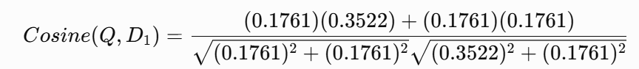
Cosine (Q, D1​) = 0.9487​
Similarly, Cosine (Q, D2​) = 0.7071 & Cosine (Q, D3​) = 0.7071

Final ranking: D1 > D2 = D3. Therefore, D1 is the most relevant document.
Q5: Recommendation system - solution

Mean ratings for co-rated movies M1, M2 and M3

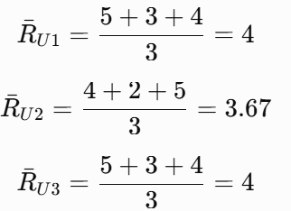

Pearson similarity formula:

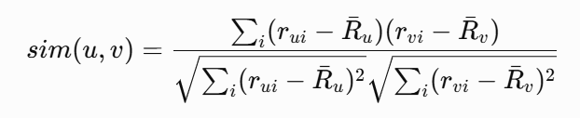

Similarity between U1 and U2 is:

U1= [5−4, 3−4, 4−4] = [1, −1, 0]

U2 = [4−3.67, 2−3.67, 5−3.67] = [0.33, −1.67, 1.33]

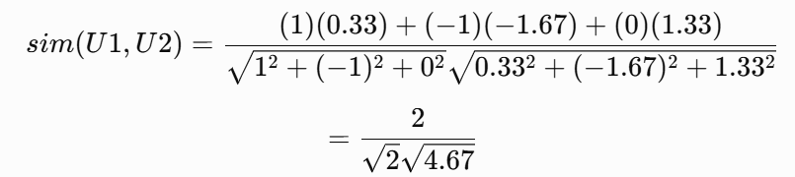
Similarly, similarity between U1 and U3 = 1

Predicted rating for M4
Overall available means are:
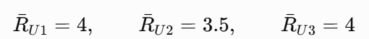
The mean-centred weighted prediction formula is:
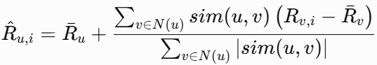
For predicting U1’s rating for M4:
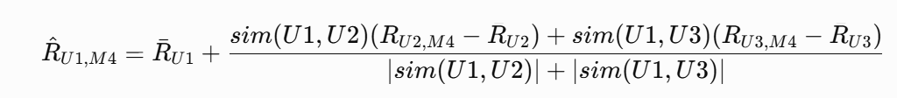
Substituting the values:
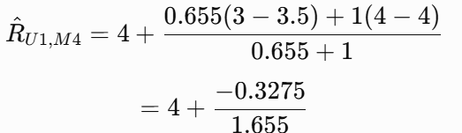
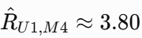
Since 3.80 > 3.5, Recommend M4 to U1.​
Q6. Multinomial Naive Bayes:

Class prior probabilities: There are four training documents:
- Sports documents = 2
- Politics documents = 2
- P(Sports) = 2/4 = 0.5 & P(Politics) = 2/4 ​ = 0.5

Vocabulary: V= {team, wins, match, player, game, minister, election, party}

∣V∣=8
Total words in each class: N_{Sports}​ = 6, N_{Politics}​ = 6
After Laplace smoothing, the denominator for both classes is: 6 + (1)(8) = 14
Conditional probabilities:
Query Word | Count in Sports | P(word∣Sports) | Count in Politics | P(word∣Politics)
team | 1 | 2/14 | 0 | 1/14
wins | 2 | 3/14 | 2 | 3/14
game | 1 | 2/14 | 0 | 1/14

Sports posterior score = Score(Sports) = 0.5 × 2/14​ × 3/14 ​× 2/14​ = 0.002187

Politics posterior score = Score(Politics) = 0.5 × 1/14 ​×3/14 ​× 1/14 = 0.000547​
Since: 0.002187 > 0.000547, the final classification is: Sports​

